Eagles #711 Newsletter-October 2023

Queen of Hearts  Queen tickets are sold at the bar daily and  at the Queen table on Mondays from  5:30 – 6:30 pm. The drawing is held at 7:00 pm. 50/50 tickets and other raffles are also held during the evening. The kitchen is open from 4:30 – 7:00 pm. Jackpot at the start of this month is over $26,000. Come in and try your luck! | OCTOBER ENTERTAINMENT  6th: Karaoke w/Wess 7:30 – 10:30 pm  13th: Chapman & Klein 8:00 – 11:00 pm  15th: Open Mic w/Jim Price 7:00 – 10:00 pm  20th: Heart Broke Band 8:00 – 11:00  21st: Karaoke w/DJ Wess 7:30 – 10:30  27th: Karaoke w/DJ Banche 7:45 – 10:30  28th: Olivia & Ryan 8:00 – 11:00 pm
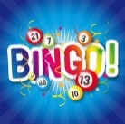  Norwalk Humane Society Bingo  at the Norwalk Eagles Club  October 4th & November 1st  Doors Open: 4:30 pm  Early Bird: 5:30 pm Regular Bingo: 6:00 pm  *Open to the Public*  Must be 18 years or older | AUXILIARY BAKE SALE  Friday, October 6th & 20th  5:30 – 9:00 pm  Enjoy dinner with us and be sure to check out the bake sale goodies. There is something to satisfy everyone’s sweet tooth. Enjoy a special dessert on Sweetest Day.
Club Meetings  Aerie: October 3rd & 17th @ 7:00 pm  Auxiliary: October 10th & 24th @ 6:30 pm  Eagle Riders: October 29th @ 1:00 pm  Zone Conference in Lima: October 13th – 15th  ******************************************************************  Club Phone Numbers  Trustees’ Office: 419-668-5602  Aerie Secretary: 419-663-7327  Kitchen: 419-663-5482  Bar: 419-668-9002  Auxiliary Office: 567-424-6189 | 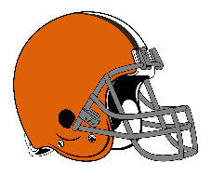  This Photo by Unknown Author is licensed under CC BY-SA  BROWNS GAMES  Sunday, October 1st, 15th, 22nd & 29th  $1.00 Day during the game!  Pizza provided by the club!  Join us, watch the game on the big screen and  cheer the Browns on to a victory!
Sweetest Day Dinner
Saturday, October 20th
5:00 – 8:00 pm
Surf & Turf
Two Lobster Tails w/Two Sides: $29.99
One Lobster Tail &10 oz Sirloin Steak
w/Two Sides: $24.99
(A limited menu will also be available.)

Special Entertainment
Heart Broke Band
8:00 – 11:00 pm

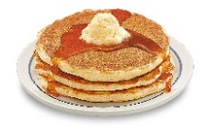
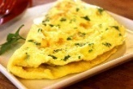
Pancake/Omelet
Breakfast
Sunday, October 1st
8:00 am – 12:00 pm
Open to the Public!
Menu: Pancakes, Made to order Omelets,Sausage, Potatoes, Biscuits & Gravy,Fruit, Juice, Milk & Coffee

Adults: $10.00
Children 10 and under: $5.00

This is a fundraiser for the
Ohio State School for the Blind.

Quote of the Month

“Too often we underestimate the power of a touch,
a smile, a kind word, a listening ear, an honest compliment, or the smallest act of caring, all of which have the power to turn a life around.”
~Leo Buscaglia~

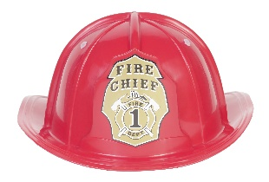  Celebrity Bartender  Fire Chief Dan Strayer  Thursday, October 12th  5:00 – 7:00 pm  In recognition of Fire Prevention Week, the NFD will be giving away fire detectors. Fire detector tips:  - Test detectors every month  - Change batteries every 6 months  - Replace detectors every 10 years  Be sure to stop in and say hello to Chief Strayer. | 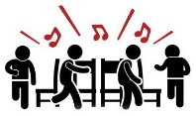  Musical Chairs  Alzheimer’s Awareness Benefit  Sponsored by the Auxiliary  Saturday, October 28th at 6:30 pm  To participate, you must sign up at the kitchen by  October 24th. Sponsor forms for pledges available at the kitchen or donations will be accepted.  See fliers on the doors for additional information.  All money raised will go to our local chapter for  Alzheimer’s Awareness.
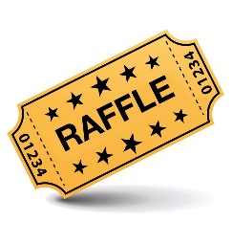  Fundraiser Raffle  “42 Chances to Win”  Wednesday, November 22nd  Drawing Begins at 8:00 pm  Need not be present to win.  $10.00 Donation to  The Ohio State School for the Blind  Tickets available at the bar and kitchen.  Only 300 tickets sold! | Saturday, October 28th @ 8:00 pm  Following the Musical Chair Fundraiser  - Costume Contest  - Special Drinks/Cider & Donuts  - Music by Olivia & Ryan
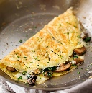  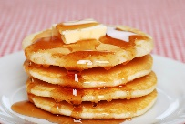  Norwalk Eagle Riders  Pancake Breakfast  Sunday, October 29th  8:00 am – 12:00 pm  Open to the Public!  Pancakes, Made to order Omelets,Sausage, Potatoes, Biscuits & Gravy, Fruit, Juice, Milk & Coffee  Adults: $10.00  Children 10 and under: $5.00  Proceeds to benefit our Christmas Charities | COMEDY NIGHT  A Salute to our Veterans  Saturday, November 11th  The Norwalk Eagles Club #711  Presents Comedians  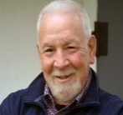  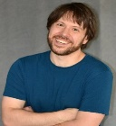  Kurt Bogos Jason Molitano Bill Boronkay  Tickets: $25.00 per person  Veterans: $12.00 per person  Includes Dinner: Turkey, Dressing,  Mashed Potatoes, Cranberry Salad & Dessert  Doors open at 6:00 pm with Cash Bar  Dinner served at 6:30 pm  This event is open to the public.  Must be 21 or older!  Presale tickets available at the Norwalk Eagles Bar  _____________________________________________________________________  New Kitchen Hours  Due to a shortage of kitchen staff, we will have new  hours starting October 1st. We apologize for the inconvenience and appreciate your understanding.  Monday (for Queen): 4:30 – 7:00 pm  Tuesday & Wednesday: 2:00 – 7:30 pm  Thursday & Friday: 2:00 – 8:00 pm  Saturday: 2:00 – 7:30 pm  Future Activities in November  - 11/3&4 Eagles Central Regional Conference in  Troy, Michigan  - 11/11 Comedy Night 11/11  - 11/12 District Meeting in Norwalk  - 11/22 “Drinksgiving” w/Bender Band and  “42 Chances to Win Raffle” 11/22  - 11/26 Eagle Riders Pancake & Omelet  Breakfast
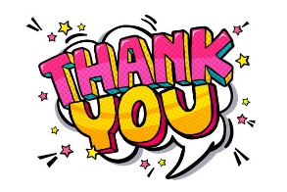
A special thank you to the following members who volunteered their time to work at the club picnic. Your help was
needed and greatly appreciated!

Mike Hornsby Victoria Capizzi
Gary McGinn Renee Grose
Bobby Norwood Dave & Deb Hougtlen
Roy Greaves

A special “shout out” to Tom Royster & Denise Roth
who worked the kitchen and to our bartenders
Beth, Kristen & Nikko!

Volunteers are always needed for various activities and events held at the club. Please check out the volunteer board on the hallway wall and fill out a card to let us know what you would like to do.

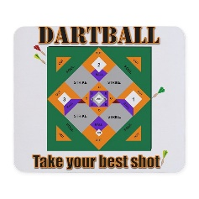
Norwalk Eagles Dartball

The Norwalk Eagles Club has two teams participating in the Huron County Dartball League. League games will be played at the club every Thursday in the big hall starting October 5th and will continue through March. Support our club teams and participate in their 50/50 drawings every Thursday night.

BIG HALL RENTAL, CARD ROOM RENTAL, &
CATERING INFORMATION

For hall or card room rentals, contact the Trustees’ Office at: 419-668-5602

Weddings – Big Hall Hourly Rental of Big Hall Card Room Rental

Members: $400 Members: $50 per hour Members: $25 per hour

Non-Members: $500 Non-Members: $75 per hour Non-Members: $40 per hour

$150 Refundable Deposit $150 Refundable Deposit $25 Refundable Deposit

Catering Available: Contact Karen in the Kitchen at: 419-663-5482

